
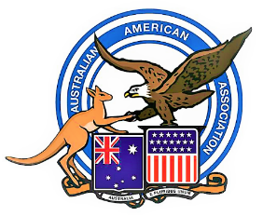
Australian American Association
Queensland Division - Brisbane

News Flash No 110 - 17 ^{th} August 2025

Address: PO Box 340 Sunnybank Qld 4109 Email: admin@aaabrisbane.com Web: www.aaabrisbane.com

Patron: Her Excellency the Hon. Dr Jeannette Young AC PSM, Governor of Qld.



Thanksgiving Dinner being held at the United Service Club, on Friday 28th November 2025.
The United Service Club is one of Brisbane’s Premium Private Members Establishments, with wonderful ambience and many years of service tradition.
The club is located at 183 Wickham Terrace, Spring Hill Brisbane, and is within easy reach of bus and train transport. Parking is available at the club and may also be found at nearby public carparks.
Official Invitations for this event will be sent out
in late September.

- For your interest and enjoyment, there will be a Guest Speaker and also, great Raffle Prizes to be won.
- The payment details for the meal & drinks will be sent to you with the Official Invitation.
- This is a Fund-Raising event and perhaps you would like to sponsor a table of 8 and/or donate a raffle prize.
- As numbers are limited, please register now if you wish, and we will reserve your places at the tables.
- If you require any further information about this event, please email: - admin@aaabrisbane.com


Looking forward to seeing you there on the night !
Regards,

Teresa Pokoj, Secretary & Life Member
Australian American Association, Brisbane.

